BONNEVILLE DAM

FISHWAY STATUS

ANNUAL REPORT

For

2004

By

Ben J. Hausmann
Tammy M. Mackey
Timothy J. Darland
Jonathan G. Rerecich

U. S. Army Corps of Engineers
CENWP-OP-B
Bonneville Lock & Dam
Cascade Locks, OR 97014
(541) 374-4552

31 December 2004
TABLE OF CONTENTS

INTRODUCTION-----------------------------------------------------------------------------------2
Figure 1. Bonneville Lock and Dam--------------------------------------2

FISHWAY OPERATION AND ACTIVITIES-----------------------------------------------3-6
Fish Passage Plan (FPP) Violations-----------------------------------------------3
STS/VBS Inspections-------------------------------------------------------------------4
Table 1. STS and VBS Inspections 2003-2004-----------------------------4
Auxiliary Water System (AWS) Closures-----------------------------------------4
Fish counts---------------------------------------------------------------------------------5
Table 5. Fish passage at Bonneville Dam for 2004-----------------------5
Zebra Mussels-----------------------------------------------------------------------------5
Avian Abatement Measures----------------------------------------------------------5
Adult Fishway Temperature Monitoring------------------------------------------6
Table 2. Average temperature in the Bradford Island fishway--------6
Table 3. Average temperature in the Washington Shore fishway----6
Table 4. Maximum temperature in the Adult Fish Facility--------------6

FISH FACILITY AND TURBINE OUTAGES----------------------------------------------7-8
Table 7. Fish Facility Outages & Maintenance----------------------------------7
Fish Unit Outages------------------------------------------------------------------------7
Table 8. Turbine Outages of at least 24 hours----------------------------------8

FISH REMOVAL------------------------------------------------------------------------------------9

GLOSSARY----------------------------------------------------------------------------------------11

REFERENCES------------------------------------------------------------------------------------12

Acronyms and jargon are used freely in this report. The reader can find definitions in the glossary.

INTRODUCTION
This document summarizes activities impacting fish at Bonneville Lock & Dam from 1 December 2003 through 30 November 2004.

Primarily a summary of weekly reports, this document is required by the Corps of Engineers’ North Pacific Division, as described in the Fish Passage Plan (FPP). The FPP contains the following surveillance and reporting requirements. “Project biologists shall inspect fish passage facilities at the frequencies listed in the juvenile and adult fish facilities operating criteria sections. The (weekly) reports shall include: any out of criteria situations observed and subsequent corrective actions taken; equipment malfunctions, breakdowns or damage, along with a summary of resulting repair activities; adult fish control calibrations; STS and VBS inspection; any unusual activities which occurred at the project which may affect fish passage.”

The Project includes two powerhouses, a spillway and two navigation locks. The older of the two navigation locks has not operated since early 1993. There are four adult fish ladders, for upstream migration, located at each powerhouse and the north and south ends of the spillway. There are three Juvenile Bypass Systems (JBS) for downstream migration: one downstream migration transportation channel (DSM) at each powerhouse and the corner collector at PH2.

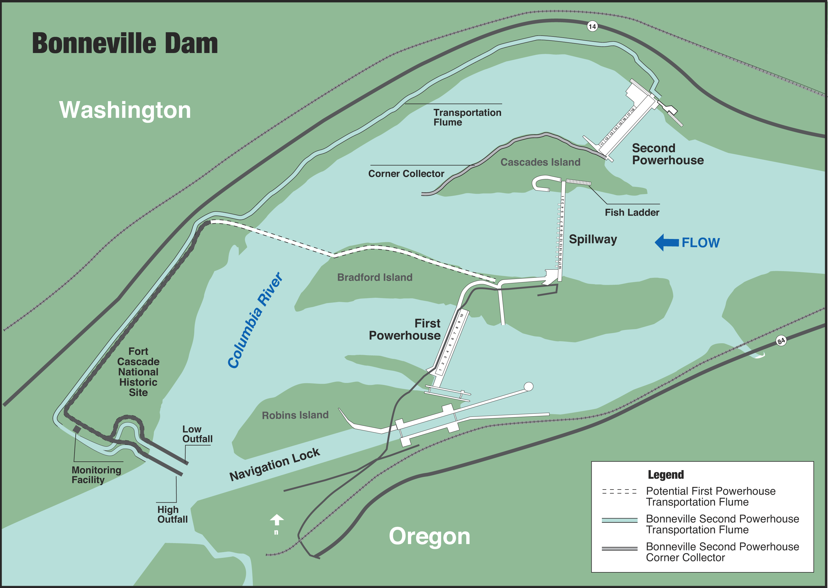
Figure 1 Bonneville Lock & Dam.

FISHWAY OPERATION AND ACTIVITIES

Fish Passage Plan (FPP) Violations
The results of 324 daily fishway inspections (23 of which were conducted by NOAA Fish, FPC, or FFU) are shown in the following table. Project Fisheries and the control room operators conduct inspections each day. Shown are the FPP violations, numbers of days the violation occurred, and the percentage of days the item was IN criteria. Items in criteria 100% of the time are not listed.
Table 1. Fish Passage Plan violations and percent in criteria.

The velocity meters were out of service or out of criteria most of the year. At PH1 the low velocities are due to an eddy in the slowest part of the collection channel. At PH2 the meter had a broken cable. The replacement meter is scheduled for installation at the south end of the channel during the winter of 04/05.
FG3-4 was out of criteria due to a bent diffuser shaft. It is unclear whether the diffuser is full open or full closed, though we treated it as closed. FG3-5 was used to compensate for FG3-4 when the water elevations were below FPP criteria. Most of the time the ladder remained in criteria even with the diffuser being out of service.

Spill bays 1 and 18 were out of criteria due to equipment safety concerns regarding the bay hoists. Adjacent bays were used to compensate for bays 1 and 18.

Weir 37 and 38 were out of criteria during early spring and late summer. The water levels were both over and under FPP criteria, usually no more than a couple tenths of a foot. AFF operations and fish blocking the weir drain were the primary causes for being out of criteria.

STS/VBS Inspections
The FPP requires submersible traveling screen (STS) inspections be conducted monthly and vertical barrier screen (VBS) inspections once every two months. Each STS has a timer that automatically shows elapsed time of operation, allowing STS inspection frequency to be measured by run time. The equivalent of one month of continuous operating time is 720 hours. Bonneville inspects both STS and VBS with an underwater video camera. Video allows STSs and VBSs to be inspected simultaneously, and eliminates the need to dip gatewells or handle fish.
Unit 8 ESBSs were permanently removed this year.

Table 2. STS and VBS Inspections 2003-2004

Auxiliary Water System (AWS) Closures
The AWSs were closed for trashrack cleaning on several occasions during the 2003-2004 reporting year. Cleaning closures ranged from eight minutes to over two hours with an average closure lasting 40 minutes. AWS trashracks were usually cleaned once each month with more frequent cleanings during late summer and early winter. This year FV1-1 and FV3-9 both had 33 closures with an average of 36 and 56 minutes (respectively) per cleaning. FV3-7 had 22 closures with an average closure time of 59 minutes.

FV4-4 was closed for three hours and FV5-3, and FV5-4 were closed for one hour to facilitate mid-season fishway inspection dives.

All AWS valves were closed from 16 until 20 January to prevent an oil spill originating upriver from entering the fishways.

Fish counts
WDFW undertakes the fish counting for all fish passing by the Washington Shore and Bradford Island fishways. From March until November, there are fish counters visually counting fish for 16 hours. From November until March, counts are video taped for 16 hours. Nighttime counts were discontinued due to cost and lack of need for the data. The following chart gives an idea of our passage numbers and peak passage times.

Table 3. Fish passage at Bonneville Dam for 2004.

Zebra Mussels
Through weekly inspections of the monitoring station at the First Powerhouse and of all dewatered fishways, we have found no indication of zebra mussel colonization. It is understood that their arrival is inevitable. We continue monitoring with hopes that control programs can be initiated at the first indication of the zebra mussel’s arrival in the Pacific Northwest.

Avian Abatement Measures
Avian lines are strung at PH1 tailrace, spillway tailrace, PH2 tailrace, and over the B2 corner collector plunge pool. All lines were intact during the fish passage season. Hazing activities on piscivorous birds were conducted from 8 March through 15 July by USDA-APHIS-WS. Non-lethal hazing techniques included 15 mm screamer shells, cracker shells, and rockets. More time was spent hazing birds at the SMF outfalls than previous years due to the avian hydro cannon being out of service. The avian cannon returned to service on 14 July.

Adult Fishway Temperature Monitoring
Project biologists monitor fishway temperatures throughout the fish passage season and the AFF primarily during the summer months. The following temperature charts illustrate temperature trends throughout the fish season. Detailed daily temperatures can be found in our weekly reports.
Table 4. Average Temperature in the Bradford Island fishway.
Table 5. Average Temperature in the Washington Shore fishway.
Table 6. Maximum Temperature in the Adult Fish Facility.

FISH FACILITY AND TURBINE OUTAGES

Fish Facility | Date Out | Date In | Reason for Outage
DSM2 | 01 Dec 2003 | 25 Feb 2004 | Winter maintenance
Cascades Island | 01 Dec 2003 | 13 Jan 2004 | Winter maintenance
AFF | 08 Dec 2003 | 13 Jan 2004 | Winter maintenance
Washington Shore | 08 Dec 2003 | 13 Jan 2004 | Winter maintenance
DSM1 | 17 Dec 2003 | 15 Sep 2004 | Out until September
DSM1 | 15 Dec 2004 | Present | Winter maintenance
DSM2 | 20 Dec 2004 | Present | Winter maintenance
Bradford Island | 16 Jan 2004 | 12 Feb 2004 | Winter maintenance
Washington Shore | 16 Jan 2004 | 20 Jan 2004 | At orifice flow due to The Dalles oil spill
Cascades Island | 16 Jan 2004 | 20 Jan 2004 | At orifice flow due to The Dalles oil spill
B2 Corner Collector | 06 Feb 2004 | 18 Feb 2004 | Closed until hydraulic tests
B2 Corner Collector | 20 Feb 2004 | 11 Mar 2004 | Closed until second Spring Creek release
B2 Corner Collector | 15 Mar 2004 | 13 Apr 2004 | Closed until 2004 spill season
Washington Shore | 10 Jul 2004 | 10 Jul 2004 | Closed to look for possible missing person
A and B branches | 03 Aug 2004 | 03 Aug 2004 | Low flow for ROV inspections
Washington Shore | 04 Aug 2004 | 04 Aug 2004 | Low flow for ROV inspections
Cascades Island | 04 Aug 2004 | 04 Aug 2004 | Low flow for ROV inspections
B2 Corner Collector | 31 Aug 2004 | Present | Closed until 2005 spill season
UMT | 24 Nov 2004 | Present | Winter maintenance
Washington Shore | 27 Nov 2004 | Present | Winter maintenance
AFF | 29 Nov 2004 | Present | Winter maintenance
Table 7. Fish Facility Outages & Maintenance

Fish Unit Outages
03 Dec 03 – 15 Jan 04 F1 OOS for testing and winter maintenance.
05 Feb 04 – 07 Feb 04 F1 OOS to facilitate dredging operations for new Fish Unit trashracks.
09 Feb 04 – 11 Feb 04 F1 OOS to facilitate dredging operations for new Fish Unit trashracks.
17 Feb 04 – 19 Feb 04 F1 OOS for rebalancing the generator.
23 Feb 04 – 24 Feb 04 F1 OOS to facilitate trashrack removal.
28 Feb 04 – 01 Mar 04 F1 OOS due to a governor failure.
29 Apr 04 – 29 Apr 04 F1 OOS because the field breaker would not close.
04 May 04 – 04 May 04 F1 OOS for trashrack raking.
23 Aug 04 – 23 Aug 04 F1 OOS for station service transfer.
27 Nov 04 – Present F1 OOS for winter maintenance at the Washington shore fishway.

03 Dec 03 – 25 Feb 04 F2 OOS for F1 testing and winter maintenance.
04 May 04 – 04 May 04 F2 OOS for trashrack raking.
16 Aug 04 -- 16 Aug 04 F2 OOS for trashrack raking.
27 Nov 04 – Present F2 OOS for winter maintenance at the Washington shore fishway.

Fish units 1 and 2 were placed on standby at other times during the year to “float” trash away from the trash racks. When drawdown measured one foot or greater, fish units were shut down. An adjacent unit was then operated to pull trash away from the fish unit trashracks. This procedure helped prevent debris and silt from accumulating in front of the fish units. Most of the unit outages associated with the floating of trash and debris occurred between midnight and 0300 to minimize impact on adult fish passage.

Turbine Unit | Date Out | Date In | Reason for Outage
1 | 10 Jun 2002 | 09 Oct 2004 | Turbine Rehab
2 | 06 Aug 2003 | 09 Dec 2003 | Crane rail replacement
3 | 06 Aug 2003 | 09 Dec 2003 | Crane rail replacement
4 | 06 Aug 2003 | 09 Dec 2003 | Crane rail replacement
11 | 17 Oct 2003 | 31 Mar 2004 | Emergency shutdown
10 | 21 Nov 2003 | 10 Dec 2003 | Exciter trouble
8 | 06 Dec 2003 | 08 Dec 2003 | ESBS failure
17 | 12 Jan 2004 | 12 Apr 2004 | VBS mods
16 | 15 Jan 2004 | 13 Jan 2004 | Brake repairs
10 | 05 Feb 2004 | 09 Feb 2004 | Upper bearing guide
10 | 11 Feb 2004 | 08 Apr 2004 | Upper bearing guide
18 | 23 Feb 2004 | 25 Feb 2004 | Wicket gate packing
2 | 08 Mar 2004 | 11 Mar 2004 | Pre rehab testing
14 | 22 Mar 2004 | 30 Mar 2004 | Wicket gate packing
17 | 26 Apr 2004 | 27 Apr 2004 | Servo motor repair
6 | 26 May 2004 | 27 May 2004 | Annual maintenance
5 | 02 Jun 2004 | 03 Jun 2004 | Annual maintenance
3 | 21 Jun 2004 | 22 Jun 2004 | Annual maintenance
4 | 23 Jun 2004 | 25 Jun 2004 | Annual maintenance
2 | 19 Jul 2004 | 23 Jul 2004 | Storing of Unit 1 tail logs
18 | 19 Jul 2004 | 09 Nov 2004 | Four year overhaul
0 | 26 Jul 2004 | Present | Five year overhaul
15 | 02 Aug 2004 | 09 Aug 2004 | Brake repairs
16 | 02 Aug 2004 | 05 Aug 2004 | Annual maintenance
17 | 02 Aug 2004 | 05 Aug 2004 | Annual maintenance
12 | 09 Aug 2004 | 10 Aug 2004 | Brake repairs
11 | 23 Aug 2004 | 26 Aug 2004 | Annual maintenance
12 | 23 Aug 2004 | 30 Aug 2004 | Annual maintenance
13 | 23 Aug 2004 | 26 Aug 2004 | Annual maintenance
14 | 23 Aug 2004 | 30 Aug 2004 | Annual maintenance
9 | 24 Aug 2004 | 06 Oct 2004 | Gantry 3 construction
10 | 24 Aug 2004 | Present | Gantry 3 construction
15 | 05 Sept 2004 | 07 Sep 2004 | STS failure
2 | 12 Oct 2004 | Present | Turbine rehab
15 | 31 Oct 2004 | 02 Nov 2004 | Loss of governor control
1 | 01 Nov 2004 | 02 Nov 2004 | Breaker repair
9 | 01 Nov 2004 | 02 Nov 2004 | Unit 1 breaker repair
11 | 15 Nov 2004 | Present | Overhaul
15 | 21 Nov 2004 | 24 Nov 2004 | Loss of governor control
Table 8. Turbine Outages of at least 24 hours

Fish Removal
Fish passage facilities and turbine units are taken out of service and dewatered to allow for inspection, preventative maintenance, repairs, and modifications. As facilities and turbine units are dewatered, project biologists, outside agency personnel, and other project personnel follow procedures detailed in the Fish Salvage Plan to minimize impacts on fish. Recovered adult salmonids and lamprey are typically released into the forebay above the new navlock; sturgeon and juvenile salmonids are released below the dam at Hamilton Island.
The following is a summary of the number of fish removed during dewaterings. All fish were recovered in good condition unless otherwise noted.
Unit 17 Draft Tube (01-16-04): One sturgeon, two juvenile steelhead.

Bradford Island exit (01-20/21-04): 155 unknown adult steelhead, two rainbow, three crayfish, one carp, about a dozen peamouth and chubs, 22 whitefish, three juvenile steelhead and two juvenile chinook.

Bradford Island Junction Pool (01-20-04): 71 wild adult steelhead, 66 hatchery adult steelhead, three juvenile steelhead, eight juvenile chinook, 11 peamouth, one stickleback, one sculpin, one whitefish, one lamprey, one bullhead, one dead juvenile salmonid sucked into the dewatering pump.

Bradford Island AWS channel (01-21-04): 21 lamprey

A-branch diffuser pools (01-21-04): 152 unknown adult steelhead

B-branch diffuser pools (01-21-04): 38 unknown adult steelhead, six juvenile steelhead, three whitefish.

PH1 South Collection Channel (02-09-04): Four juvenile salmonids, nine sculpin, one northern pikeminnow, four crayfish.

New Navlock (03-07-04): 2000 subyearling chinook, 100 yearling chinook, three adult steelhead, 60 crawdads, 24 sculpin, one smallmouth bass, one crappie, one tadpole, couple dozen sticklebacks.

Unit 1 tail logs (7/19-22/04): Nine sturgeon, one smallmouth bass, 100 sculpin, three juvenile lamprey, two catfish and 107 crayfish.

Unit 18 draft tube (7-20-04): 20 sturgeon, 25 subyearling chinook, six lamprey, two catfish, one northern pikeminnow.

Unit 0 (7-29-04): one dead lamprey, one dead juvenile smallmouth bass, one dead sturgeon, one subyearling chinook, and one three-spined stickleback.

AFF beginning of exit ladder in lab (9-07-04): moved 80-100 adult chinook, approximately 6 lamprey, a couple of steelhead and a couple of shad to the main section of the exit ladder.

Washington Shore ladder and AFF (11-29-04): moved several dozen steelhead and coho down the ladder. Rescued eight adult steelhead and 30 sculpin, peamouth and suckers from the UMT; 12 shad, three adult steelhead, one juvenile steelhead, one rainbow and 24 peamouth and suckers from the AFF; two adult steelhead, 24 peamouth, suckers and sculpin, and 250-300 lamprey (80 given to the Warm Springs Tribes) from the Washington Shore fishway.
GLOSSARY
AFF----- Adult Fish Facility. Lab associated with the Washington Shore ladder. Adult fish are trapped for research purposes.
B2CC---- Powerhouse Two Corner Collector. A surface bypass system located in the southern corner of the Bonneville Second Powerhouse forebay.
BiOp Biological Opinion.
BON Bonneville Lock & Dam.
Downwell Opening through which water and fish drop after excess water is drawn away through a dewatering screen. Start of the transport conduit for fish from DSM1 to the tailrace.
DSM 1-- Downstream Migrant transportation channel (PH1). Transport channel for juvenile fish from gatewell orifices to the downwell.
DSM 2-- Downstream Migrant transportation channel (PH2). Transport channel for juvenile fish from gatewell orifices to the juvenile transport pipe.
CRITFC Columbia River Intertribal Fish Commission.
FFU----- Fisheries Field Unit. Unit in the Corps of Engineers’ Portland District Construction, Operations Division that conducts fish related evaluations and monitoring.
Forebay That area of a reservoir immediately upstream of a dam.
FPC Fish Passage Center.
FPP Fish Passage Plan.
JBS Juvenile Fish Bypass System.
Kcfs Thousand cubic feet per second.
NDE----- North Downstream Entrance. Refers to one of the four large overflow weir adult fishway entrances at PH2.
NUE North Upstream Entrance. See NDE.
NOAA Fish National Oceanic and Atmospheric Administration Fisheries. Formerly known as NMFS.
ODFW Oregon Department of Fish & Wildlife
OOS Out Of Service.
PCC----- Powerhouse Collection Channel. Part of the adult fishway spanning the length of the downstream side of each powerhouse.
PH1 Bonneville First Powerhouse.
PH2 Bonneville Second Powerhouse.
PIT ------ Passive Integrated Transponder. A tag inserted into juvenile and adult fish. Detectors are installed at all fish passage systems.
Project Bonneville Lock & Dam.
SDE South Downstream Entrance. See NDE.
SMF Smolt Monitoring Facility. Lab associated with the PH2 JBS.
SUE South Upstream Entrance. See NDE.
STS Submersible Traveling Screen.
Tailwater The portion of a river immediately downstream of a dam or powerhouse.
TIES Turbine Intake Extension Screen.
Tule Early spawning fall chinook.
UMT----- Upstream Migrant Transportation channel. This channel connects Cascades Island ladder to Washington Shore ladder through PH2.
VBS Vertical Barrier Screen.
WDFW Washington Department of Fish & Wildlife.

REFERENCES

2003. Fish Passage Plan for Corps of Engineers Projects. U. S. Army Corps of Engineers, North
Pacific Division, Portland, Oregon.

2004. Fish Passage Plan for Corps of Engineers Projects. U. S. Army Corps of Engineers, North
Pacific Division, Portland, Oregon.

